CSA5103 – Cryptography and Network Security
Lab Experiments

Name: K. Teja Sri
Register No: 192525249

Exp.No-1

- Write a C program for Caesar cipher involves replacing each letter of the alphabet with the letter standing k places further down the alphabet, fork in the range 1 through 25.

Aim:
To implement the Caesar Cipher algorithm for encryption and decryption using Python.

Algorithm:
- Start.
- Read the message and key value (1–25).
- Encrypt each letter by shifting it k positions forward.
- Display the encrypted message.
- Decrypt the encrypted message by shifting it k positions backward.
- Display the decrypted message.
- Stop.

Program:
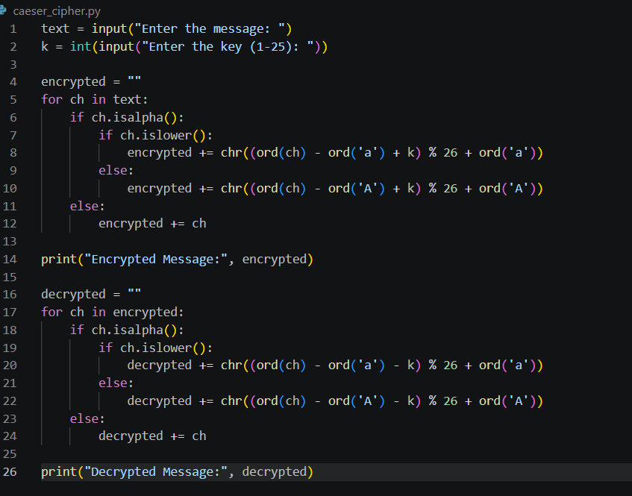

Output:
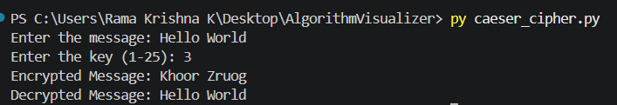

Result:
The Caesar Cipher algorithm was successfully implemented. The plaintext was encrypted using the given key, and the original message was correctly recovered through decryption.

